**Music streaming app**

Designing a database for a music streaming service like Spotify involves several interconnected entities to manage users, songs, playlists, artists, albums, and more.

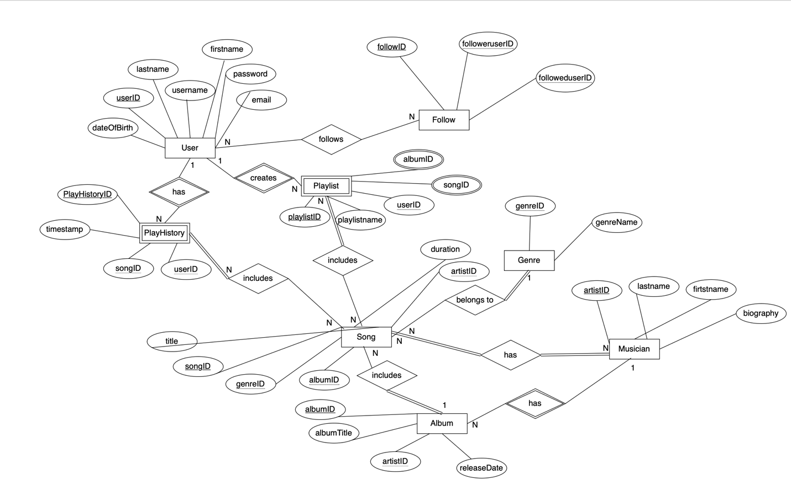

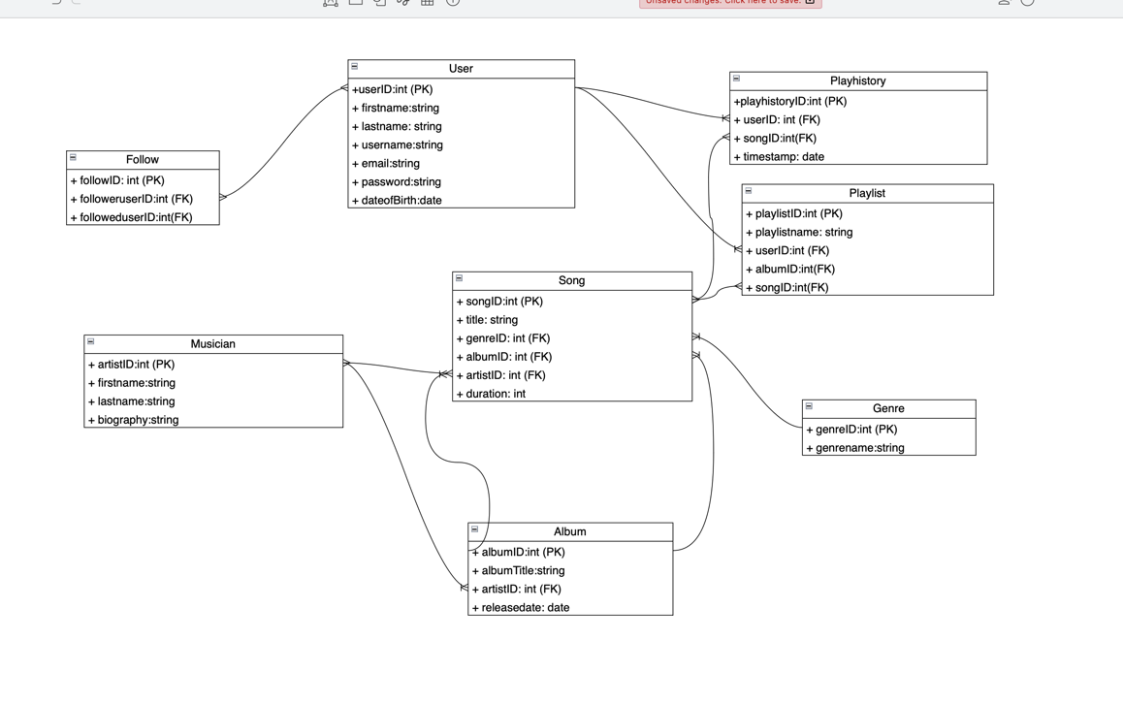

**Explanation:**

*Entities and Relationships:*

*Entities:*

**User:**

creates multiple Playlists.

Follows other Users through Follow relationship.

Records PlayHistory for listened Songs.

**Song:**

Belongs to an Artist.

Belongs to an Album.

Included in multiple PlayHistory records by Users.

**Playlist:**

Created by a User.

Contains multiple Songs.

**Musician:**

Creates multiple Songs.

Belongs to multiple Songs.

**Album:**

Contains multiple Songs.

Belongs to an Artist.

**Genre:**

Associated with multiple Songs.

**Follow:**

Connects a User to other followed Users.

**PlayHistory:**

Records songs listened to by a User.

*Relations:*

Follows =relationship type between user and follow

Has=relationship type between user and play history, musician and album

Creates=relationship type between user and play list

Includes=relationship type between play history and song, play list and user, album and song.

Belongs to=relationship type between song and genre

***Key Attribute:***

**UserID** in the User entity type

**SongID** in the Song entity type

**PlaylistID** in the Playlist entity type

**ArtistID** in the Artist entity type

**AlbumID** in the Album entity type

**GenreID** in the Genre entity type